**DX Spots Window**

*Created with the Personal Edition of HelpNDoc: [Easily create Qt Help files](http://www.helpndoc.com/feature-tour)*

**DX Spots Window**

# Hal Miller KB1ZQ, Geoff Anderson G3NPA, Jim Hargrave W5IFP, Aki Yoshida JA1NLX and Gerry Hohn VE6LB

### 2.10.10 Load LoTW ~~LotW~~ user file from Club Log

To download the LoTW users file from Club Log, right click on the DX Spot Window, left Click SETUP | LOAD LOTW USERS FILE (from Club Log) This file contains not only callsign but more recent LoTW upload date, more recent Club Log upload date, status of OQRS user or not and Grid Square. Club Log updates this file once a week (on Sunday UTC).

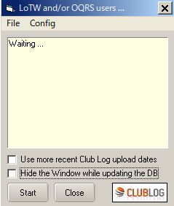

New DXSW_30A

Logger32 shows LoTW user and/or OQRS user on DX Spot Window, BandMap and Logbook Page Window. If you prefer it shows LoTW/OQRS user based on recent Club Log upload date instead of recent LoTW upload date. Check “Use more recent Club Log upload date” in this case.

Click “Start” to download the file.

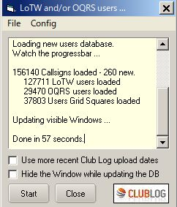

New DXSW_30B

The downloaded file is saved as clublog_users.json in the Logger32 folder. The following is a part of the json file.

{"call":"JA1NLX","firstqso":"1963-02-28 08:00:00","lastqso":"2017-05-23 09:24:40","lastupload":"2017-05-23 10:01:01","locator":"PM95SM","oqrs":"true","last-lotw":"2017-05-18 02:26:05"},

Click “Config” to select more option.

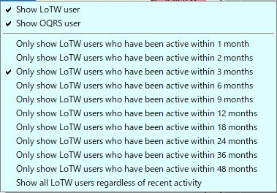

DXSW_30C

The special tips is displayed on DX Spot Window, BandMap. and Logbook Entry Window. Select the LoTW/OQRS user’s mark in each window.

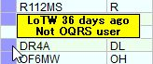

DXSW_30D

Tooltips are displayed in different styles depending on your settings. Some examples below.

If both “Show LoTW users” and “Show OQRS users” options are checked then tooltips are displayed in 2 lines, upper for LoTW user and lower for OQRS user. See DXSW_30D.

If either of these options is checked then tooltips are displayed in 1 line. (LoTW info or OQRS info) Example with “Show LoTW user” checked below.



DXSW_30E

Example with “Show OQRS user” checked below.



DXSW_30F

**Clicking DX Spot**

If Club log knows the Grid Square of a user, when you click on a DX Spot of that user, the Grid Square automatically populates the Grid Square field in the Logbook Entry Window (if Logger32 has not already found the Grid Square elsewhere).